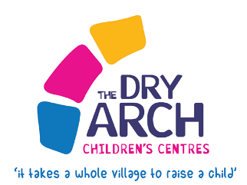
INTER-AGENCY/SELF
EXPRESSION OF INTEREST FORM

Date of Referral:
Parent/Carer’s Information
Family Name: | Mother’s First Name:
Mother’s Surname Name: | Mother’s D.O.B.
Father’s/Male Carer’s Name: | Father’s/Male Carer’s D.O.B.

Child/Children’s Full Name(s):
Ante-Natal: | Due Date:
Child 1 | Child 1 D.O.B
Child 2 | Child 2 D.O.B
Child 3 | Child 3 D.O.B
Child 4 | Child 4 D.O.B
Child 5 | Child 5 D.O.B
Child 6 | Child 6 D.O.B

Address: | Post Code:
Contact Number Home/Mobile:

Referred by: | Role: | Organisation:
Referrer’s email: | Contact:
Informed consent received for referral to Dry Arch is ESSENTIAL. Yes No (Please tick)

(Please note: Parental consent needs to be sought for any young person under 18)
Please reflect on the needs of the family below, so we can assure the best outcome.

Please include details of other professional’s involved and previous supports given.

Can you provide details of what your ongoing role with this family will be:

Signed: Date:

